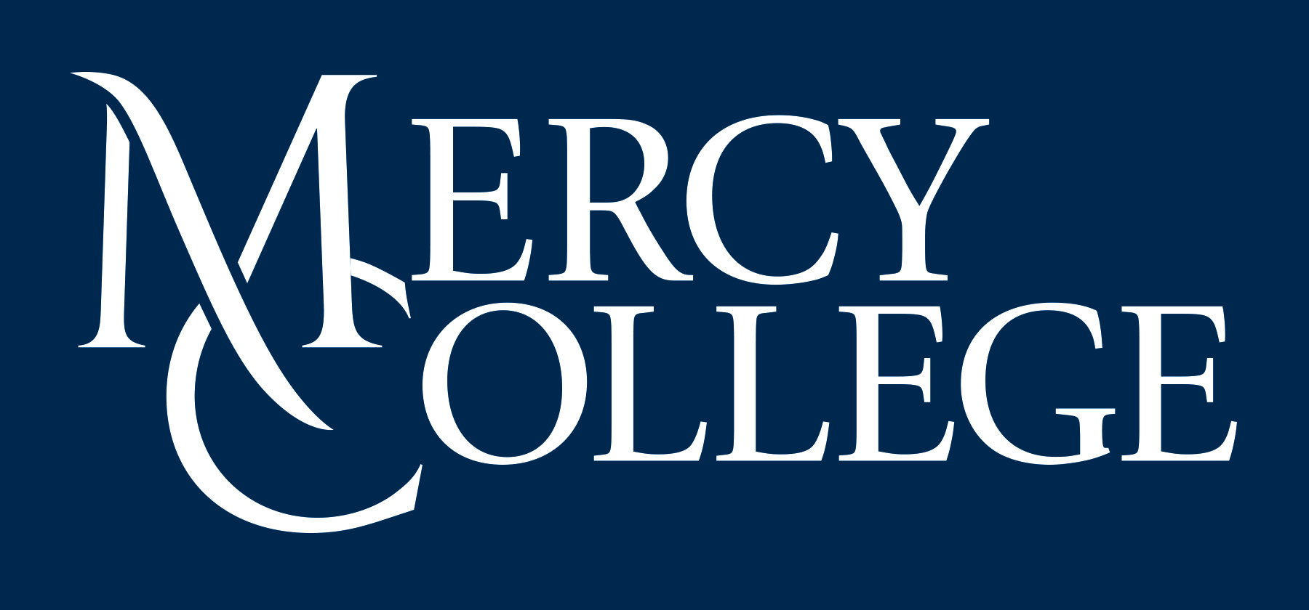
General Counsel
Mercy College
555 Broadway
Dobbs Ferry, NY 10522
Tel: 914-674-7544

MEMORANDUM
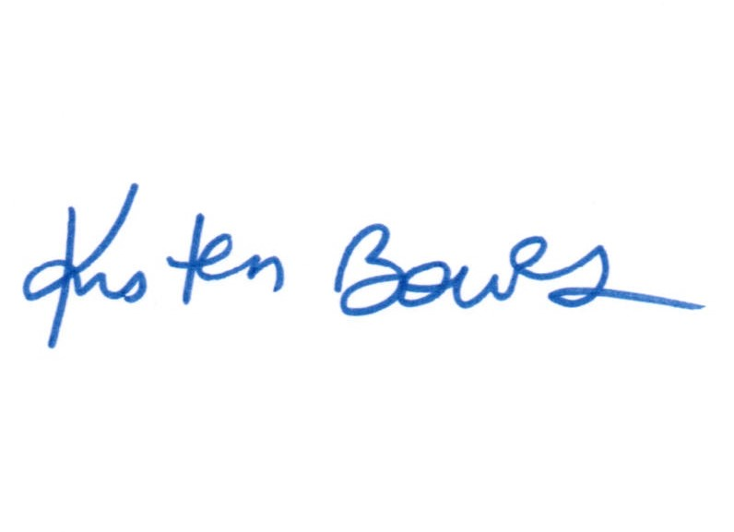
To: Mercy College Community

From: Kristen Bowes, General Counsel

Date: August 30, 2022

Re: Non-Academic Policy Review Committee, 2021-2022 Annual Summary
______________________________________________________________________________

Created back in fall 2015 by President Hall, the main role of the Non-Academic Policy Review Committee (“Policy Committee”) is to draft, revise and review policies to maintain compliance with all local, state and federal laws and regulations, and to ensure the College is adhering to best practices in operating all of its campus departments and programs. The Committee is made up of the following College representatives (and members from the 2021-2022 academic year included): Provost (Dr. Eva Fernández), General Counsel (Kristen Bowes), Assistant General Counsel (Susan Mulliken), Chief of Staff (Jessica Haber), Chief Financial Officer (Brett Carroll), Vice President for Operations and Facilities (Tom Simmonds), Vice President for Academic Affairs (Kevin Joyce), Director of Human Resources (Annette Piecora), Faculty Senate President (Roseanne Vallice Levy), Faculty Association President (Helge Wasmuth), UAW union employee representative (Sharon Garrant), and student (Angie Jaramillo). Dean Peter West, Associate Professor Susan Gaskin-Noel and Professor John Dugan also assisted the Committee during the year. The new faculty Senate President, Associate Professor Matt Hyland, will be joining the Committee on September 1, 2022.

This past academic year (September 2021 through August 2022), the Policy Committee was hard at work, meeting almost monthly even during COVID. Between August 2021 through the end of the academic term, the Policy Committee reviewed and revised 22 policies, not including the various COVID Policy revisions and updates. The Committee recommended the policies to President Hall, who then adopted them. All of the policies can be found on the College’s website at https://www.mercy.edu/about/mercy-college-policies.

Some of these non-COVID-19 related policies drafted and/or revised and reviewed by the Policy Committee last academic year, and their key points or changes, include the following:

- Sexual Misconduct Policy (revised and replaces the previous Interim policy): The key changes are the separation of processes for Non-Title IX and Title IX incidents. A matter is only a Title IX case when fits the criteria, such that the allegations meet the definition of Title IX Sexual Harassment; at the time of the allegations, the complainant is participating in, or attempting to participate in an education program or activity at Mercy; and Complainant filed a formal complaint. If an allegation does not meet these criteria, then it is handled under the Non-Title IX Sexual Misconduct process.
- Whistleblower Policy (revised): Last spring, New York State amended its Labor Law with regard to requirements for employer Whistleblower Policies. While keeping the Whistleblower namely intact, some of the additions to the Policy include:
- Individuals who reasonably believe violations have taken place should report;
- Broader definition of what can be reported, such as for violations of executive orders and administrative decisions;
- Former employees can now report suspected violations;
- Broader definition of what is considered retaliation (such as threatening to report someone or their family to immigration, etc.);
- Remedies for retaliation; and
- Physical posting of the Policy is now required (online is not sufficient).
- Equal Opportunity and Non-Discrimination Policy (revised): The Policy remained mostly intact, with just the one substantive change regarding the appeals process--changed from an appeal panel to review of the appeal by an objective administrator.
- Acceptable Use of Computer and Network Resources (revised): This Policy was revised with recommendations from the College’s IT consultant to keep up with changes in technology. In addition, Mercy is required to comply with the New York State Electronic Monitoring Notice, which requires Mercy to provide the following notice: Mercy will make every reasonable effort to respect a user's privacy. However, community members, including employees and students, do not have a right of privacy for communications transmitted or stored on the Mercy’s resources. In addition, while the College does not routinely monitor or access its mail systems, to the extent permitted by law, the College reserves the right to access and disclose, and monitor when necessary, the contents of electronic communications made with or through the College’s resources without the consent of the user. Further, any and all telephone conversations or transmissions, electronic mail or transmissions (as discussed above), or internet access or usage by a user by any electronic device or system, including but not limited to the use of a computer, telephone, wire, radio or electromagnetic, photoelectronic or photo-optical systems (“User Activity”), may be subject to monitoring at any and all times and by any lawful means.
- Nursing Parent Room Policy (revised): Replaces the previous Lactation Room Policy, with just minor updates to be more relevant to campus life.
- Remote Work Policy (new): This policy is to seek the balance of remote and in-person on-campus work that best meets the needs of Mercy College and its employees while assuring the fundamental in-person character of the institution is maintained. Remote work is a voluntary work alternative that is appropriate for some employees and some jobs but not all employees and all positions. This Policy applies to all full-time and part-time eligible Mercy College employees. This Policy does not apply to full-time and part-time faculty.
- Drug and Alcohol Policy (new): Mercy College is committed to providing a safe, healthy, and productive educational and work environment for its students and employees. In furtherance of this goal and in keeping with the requirements of the Drug-Free Schools and Communities Act and the Drug-Free Workplace Act, all students and employees are required to abide by the Mercy College Drug and Alcohol Policy. Individuals who violate this policy are subject to disciplinary sanctions including suspension and expulsion for students, and discharge for employees. Recognizing that drug and alcohol abuse are serious health concerns, this policy includes support resources for students and employees.
- Records Retention Policy and Schedule (revised): This Policy and Procedures provide for the systematic review, retention and destruction of documents received or created in the transaction of Mercy College (“College”) business. The policy is designed to ensure compliance with federal and state laws and regulations, to eliminate accidental or innocent document destruction of records and to facilitate College operations by promoting efficiency and reducing unnecessary storage of documents. The retention periods set forth in the attached Records Retention and Disposal Schedule are the minimum retention periods required by the College. At the conclusion of the retention period, the Records should be properly disposed of under this Policy. Requests to deviate from or modify this Policy or these retention periods must be made to the General Counsel. Currently the College is in the process of destroying and/or scanning documents no longer needed to be kept in accordance with he revised Records Retention schedule.
- Social Media Policy (new): Mercy College recognizes that the internet provides unique opportunities to participate in interactive discussions and share information on particular topics using a wide variety of social media, such as Facebook, LinkedIn, Twitter, Instagram, Pinterest, TikTok, blogs, and wikis. However, use of social media by employees and official College student clubs, organizations and athletic teams can pose risks to Mercy’s confidential and proprietary information, reputation, and brands, can expose the College to discrimination and harassment claims, and can jeopardize the College's compliance with business rules and laws. To minimize these business and legal risks, to avoid loss of productivity and distraction from employees' job performance, and to ensure that the College's Information Technology (IT) resources and communications systems are used appropriately as explained below, Mercy College expects its employees and official student clubs, organizations and athletic teams to adhere to the following guidelines and rules regarding social media use.
- Name Change Policy for Employees (new): Mercy College recognizes that certain circumstances may make it necessary for Mercy employees to request a name change for employee records. Official employee records, such as W-2 forms, records concerning payroll and healthcare and retirement benefits, and employment verification letters may be changed following a court-ordered or other legal name change. Unofficial employee records, such as employee identification cards, College email addresses, directory information and faculty names as they appear in Blackboard or on class rosters, may be changed to reflect a Preferred Name.
- Policy for Handling Student Complaints (revised) Minor updates to the Policy to ensure the process for handling complaints is clear. The purpose of this Policy is to provide a process whereby current students can file a complaint with the College in circumstances where the student feels that the matter cannot be resolved informally, including but not limited to: • Complaints against faculty in academic settings; • Complaints relating to other employees, contractors or vendors for misconduct or unprofessional behavior; • Complaints in connection with student services such as billing, tuition and financial aid; • Complaints related to College services, such as food services, residential life, athletics and/or health and wellness; or • Consumer complaints.
- Privacy Policy (revised): Updates were made to ensure Mercy is in line with industry standards with respect to collecting and storing data on its website.
- Facilities License Policy and Agreement (new): The purpose of this policy is to set forth the guidelines for events held by External Groups on any Mercy College (“Mercy” or the “College”) campus or property. For the purposes of this Policy, “External Groups” are any group, organization, person or program not affiliated with the College requesting use of the College’s facilities, resources and/or property (hereinafter referred to collectively as “facilities”) for an event, activity, conference, workshop, meeting, or seminar that is not a College function. All requests by any External Group to conduct any activity on the College’s campuses or locations must be submitted in advance to the Director of Community Programs and Events for approval before any agreements or contracts are undertaken with the External Group.
- Policy Regarding Gifts, Awards and Prizes with College Funds (new): Mercy College’s mission is to transform students’ lives through higher education, in an affordable manner. Consistent with that mission, the College must always seek to be judicious in the use of its resources. In addition, the College must remain compliant with federal and state tax laws relating to gifts. As such, while the administration wants to show support and sympathy to its community members in certain situations, it cannot do so in an unlimited fashion. This Policy discusses the limitations placed on expressions of sympathy, employee recognition and gifts, prizes and awards to employees, development gifts and institutional gifts.
- Policy for Handling Gift Cards (new): The purpose of this Policy is to set forth the guidelines and procedures for the purchase and distribution of gifts and gift cards/certificates purchased with College funds to ensure compliance with the College’s tax withholding and reporting obligations. Gift cards may not be purchased via College credit cards; rather, all gift card requests must be made through the College Purchasing Department in order to ensure compliance with this policy.

Currently, the Policy Committee is reviewing a substantially revised version of the Employee Human Resources Manual. The final version is expected to be approved within the coming weeks. That will be posted on the website and Mercy Connect upon its adoption.
Finally, in keeping with President Hall’s philosophy of ensuring open, transparent operations, part of the Policy Committee’s process is to solicit input and seek recommendations from all College community members of policies that they believe the Committee should consider for review. This can be done by contacting me directly at kbowes@mercy.edu, or any member of the Policy Committee.

